**The status of VHL-deficiency in ccRCC cancer**

RCC major subtypes (≥ 5%) include clear cell RCC (ccRCC) at ∼75%, papillary RCC (pRCC) at ∼15%, and chromophobe RCC (chRCC) at ∼5%. Among the ccRCC cases, the loss of heterozygosity of chromosome 3p occurs in more than 90% of the cases.(Hsieh et al., 2018(Inamura, 2017)

So in general, 60% of RCC patients bear the specialty of VHL deficiency.

**HIF-1α & HIF-2α comparation**

1. Cell lines- expression in RCC cells  
   ccRCC can be classified into three groups
   1. cells with wild type VHL
   2. cells with defective pVHL and expressing both HIF-1α and HIF-2α together
   3. cells with defective pVHL and expressing HIF-2α exclusively.
2. Translation
   1. HIF-1α & HIF-2α are post-translationally regulated via variable mechanisms.(Keith et al., 2012)

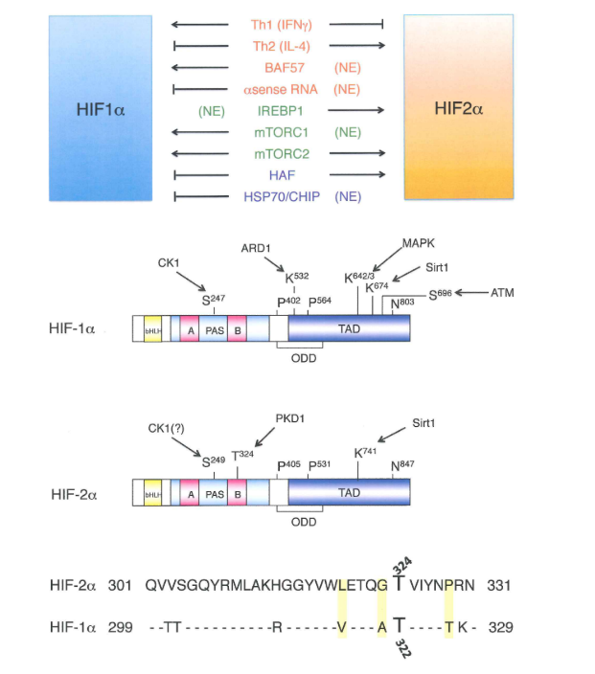

Nuclear factor-KB (NF-KB) regulates the transcription of the Hif1α gene. Moreover, Th1 cytokines stimulate this NF-κB-HIF1α pathway to activate a range of HIF1α target genes, whereas Th2 cytokines interleukin-4 (IL-4) and IL-10 differentially activate Epas1 expression, although the precise mechanisms involved are not clear.

1. Opposing functions and Regulation of HIF-1α & HIF-2α
   1. reciprocal interactions between HIF-1α & HIF-2α level in RCC.(Raval et al., 2005)  
      expression of HIF-1 in 786-O cells suppressed HIF-2; overexpression of HIF-2 strikingly downregulated HIF-1 in RCC4 cells.(Schoedel et al., 2016)
   2. Both HIF-1α and HIF-2α display different susceptibility to FIH1 and PHD-mediated prolyl hydroxylation. The CTAD of HIF-1α appears to be preferentially hydroxylated by FIH1.
   3. Loss of VHL in tubular cells primarily leads to stabilization of HIF-1α and de novo release of HIF-2α with increased expression of their target genes along with a disturbed ratio between HIF-1α & HIF-2α and additional HIF-dependent or independent events are necessary to overcome cell senescence and to promote tumor progression.
   4. the release of HIF-2α expression is an early event in pVHL-defective tubular cells; HIF-2α has tumorigenic activity, whereas HIF-1α is antitumorigenic in RCC.
      1. HIF-1α reduces MYC transcriptional activity,HIF-2α enhances MYC activity in malignant cells and, in doing so, increases the expression of cell cycle regulators such as cyclin D2.
      2. HIF1α expression in RCC cell lines appears to be regulated by both mTORC1 and mTORC2 kinase complexes, whereas HIF2α expression is mTORC2-dependent and mTORC1-independent(Keith et al., 2012)
      3. HIF-2α can inhibit p53 phosphorylation, HIF-2α knockdown leads to increased p53 protein and activity promoting cell cycle arrest, increased cell death, and reduced colony formation.
2. Targeted downstream genes(Schoedel et al., 2016)
   1. CYCLIN D1 , a crucial oncogene in RCC is exclusively regulated by the HIF-2α subunit.(Schoedel et al., 2016)(Raval et al., 2005)
   2. a significantly higher level of HIF1α binding was associated with glycolytic pathway genes. (Table 1 below: Selected genes regulated by HIF in RCC)

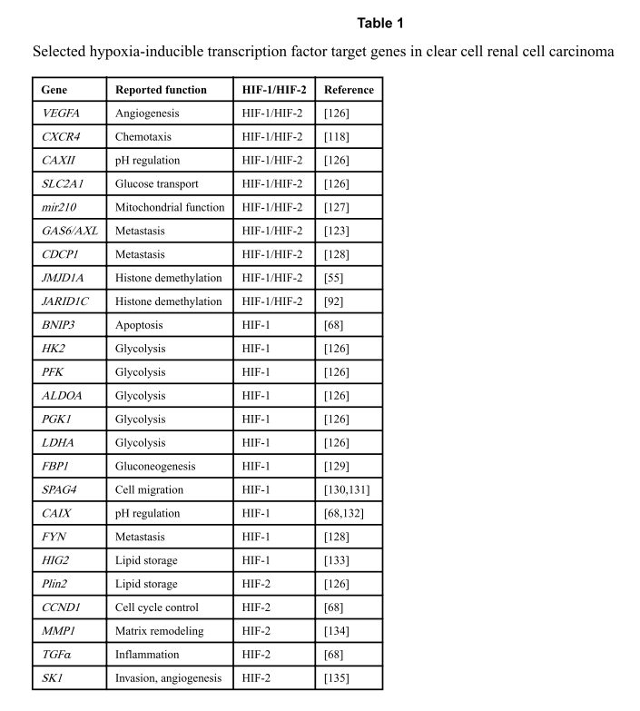

**The VHL function**

1. **Best described and highly related to pathogenesis**: the clearance of proline-hydroxylated HIF-α subunits from normoxic cells.
2. **Other functions**:
   1. targets protein kinase C and Rpb1(Schoedel et al., 2016)
   2. interacting with microtubules and promoting correct cilia formation > (contribute to formation of cysts which is a typical feature of ccRCC)(Kaelin, 2008)(Haase & Liggett, 2009)

**Clinical and therapeutic approaches**

Current therapies for advanced ccRCC already target components of the HIF pathway such as HIF translation (mTOR inhibitors) or the function of important HIF target genes (VEGFA inhibitors). However, no evidence is shown that there is correlation between level of HIF expression and response to these targeted therapies.(Schoedel et al., 2016)

Insight into resistance(Rini & Atkins, 2009)

1. mutation in a gene encoding a key receptor tyrosine kinase targeted by the drug.(which is unlikely due to the quick response of all patients)
2. physiological changes in the microenvironment; revascularization. (which might linked to HIF up-regulation)
3. upregulation of alternative proteins or pathways.(e.g. Tie2/Ang2 axis)

References

Haase, V. H., & Liggett. (2009). The VHL tumor suppressor: master regulator of HIF. *Current Pharmaceutical Design*, *15*(33), 3895–3903. https://doi.org/10.2174/138161209789649394

Hsieh, J. J., Le, V., Cao, D., Cheng, E. H., & Creighton, C. J. (2018). Genomic classifications of renal cell carcinoma: a critical step towards the future application of personalized kidney cancer care with pan-omics precision. In *Journal of Pathology* (Vol. 244, Issue 5, pp. 525–537). John Wiley and Sons Ltd. https://doi.org/10.1002/path.5022

Inamura, K. (2017). Renal cell tumors: Understanding their molecular pathological epidemiology and the 2016 WHO classification. In *International Journal of Molecular Sciences* (Vol. 18, Issue 10). MDPI AG. https://doi.org/10.3390/ijms18102195

Kaelin, W. G. (2008). The von Hippel-Lindau tumour suppressor protein: O2 sensing and cancer. *Nature Reviews Cancer*, *8*(11), 865–873. https://doi.org/10.1038/nrc2502

Keith, B., Johnson, R. S., & Simon, M. C. (2012). HIF1 α and HIF2 α: sibling rivalry in hypoxic tumour growth and progression. In *Nature Reviews Cancer* (Vol. 12, Issue 1, pp. 9–22). https://doi.org/10.1038/nrc3183

Raval, R. R., Lau, K. W., Tran, M. G. B., Sowter, H. M., Mandriota, S. J., Li, J. L., Pugh, C. W., Maxwell, P. H., Harris, A. L., & Ratcliffe, P. J. (2005). Contrasting properties of hypoxia-inducible factor 1 (HIF-1) and HIF-2 in von Hippel-Lindau-associated renal cell carcinoma. *MOLECULAR AND CELLULAR BIOLOGY*, *25*(13), 5675–5686. https://doi.org/10.1128/MCB.25.13.5675-5686.2005

Rini, B. I., & Atkins, M. B. (2009). Resistance to targeted therapy in renal-cell carcinoma. *LANCET ONCOLOGY*, *10*(10), 992–1000. https://doi.org/10.1016/S1470-2045(09)70240-2

Schoedel, J., Grampp, S., Maher, E. R., Moch, H., Ratcliffe, P. J., Russo, P., & Mole, D. R. (2016). Hypoxia, Hypoxia-inducible Transcription Factors, and Renal Cancer. *EUROPEAN UROLOGY*, *69*(4), 646–657. https://doi.org/10.1016/j.eururo.2015.08.007